ZJ-45B wireless call system operation manual
I Function description:
This system supports one-button, two-buttons, 4-buttons transmitter. Boot the host ,then all the digital tube display all 8 for about 0.5 seconds, if followed to show four 4, indicating a 4-button call mode, or show four 2 , indicating two-button call mode. Through long touch the “MODE ” button on the host for 5 seconds, can be realized to switch two-button call mode and four-button call mode. If the digital tube displays "2-4" means two-button call mode is converted to 4-button call mode. If the digital tube displays "4-2" means 4-button call mode is converted to two-button call mode (Note: must be re-power on the host to take effect).
(Because your transmitter is two-button’s, please use two-button call mode)

II The product configuration:
- the host and its screeen
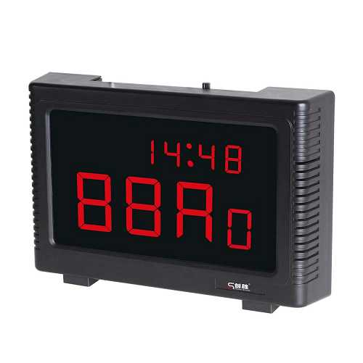
2. the managing controller(for manage the host and its screen)
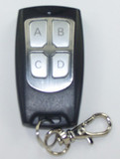

3. transmitter
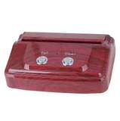
III Key diagram and their functions:

１.Key diagram on the host:
STU- study to code；
CLR-clear the call numer on the screen；
SET—the clock Setting；
MODE—switch two-button call mode and 4-button call mode.

２. Key diagram on the screen
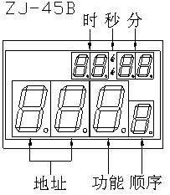

时——hand 秒——second 分——minute
地址——the call numer
功能——call for what
顺序——sequence

3. Key diagram on 4-button control (the managing controller)
A：clear (anyone of the called number on the screen)
B：clear screen (all the called number)
C：up
D：down
IV How to do the managing controller’s studying:
Push 【STU】 on the host to enter the studying state.when the host screen display “00-”, push any one of the buttons of a managing conroller（4-button control）.The screen will display “00F”,it means the managing controller is finished for studying.After about one second the screen will display “00-” again,you can to do other managing controller’s studying. A total of five managing controllers can be studied.
The studied managing controller can be used to code the transmitters,and use the button “A” or “B” or “C” or “D” to do “clear” or “clear screen” or “up” o r“study”.

V How to code the number of the transmitters:
①Clear the recorded call number in the host:
Push 【STU】 on the host for 0.5 second until the host screen display "0000" and flash once, all remembered call number in the host are cleared.
Push 【CLR】on the host for 0.5 second until the host screen display “- - - -” and flash once, accompanied by music, all called number in the host are cleared.
Push “A” button of the managing controller, all called number in the host can be cleared,too.
Push “B” button of the managing controller, all number on the screen are cleared(but is still in the host).
②Login the transmitter number:
Push “D” of the the managing controller to enter the studying state that can be coded , the host screen will display “00- ”, then push “C” button of the managing controller or “up” button on the host made the host screen display “01-”.
Next push any one of the buttons of a transmitter, when the host screen display “01F” for about 0.5 second, the transmitter have been coded NO.1 .
Then push any one of the buttons of the other transmitter , when the host screen display “02-” for about 0.5 second, it means the transmitter have been code NO.2… …
A total of 99 transmitters can be coded from NO.1 to NO.99.
When all transmitters have been coded, push 【C】 on the managing controller to log off the state that can be encoded.
VI How to inquiry the called number:
A short click “c” button of the managing controller or 【UP】、【DOWN】on the host ,you can inquiry all ten called number on the host screen.

